**Customer Segmentation & RFM Dashboard**

**Name: Kanaka Ravi**

**Batch: DA-TE-BN002**

**Project Overview**

This project delivers a data-driven **Customer Analytics Dashboard** designed to evaluate customer behavior, churn probability, and revenue contribution through **RFM (Recency, Frequency, Monetary) analysis**.

The pipeline involved:

* Extracting raw data from a **SQL database**,
* Cleaning and transforming datasets,
* Designing **stored procedures** for repeatable insights,
* Integrating SQL with **Python for visualization**,
* Building an interactive **dashboard** to support decision-making.

The outcome is a robust analytical tool that provides actionable visibility into customer segments, churn risk, cancellations, and revenue channels.

**Key Insights**

1. **Customer Segmentation**
   * **Regulars (45.7%)** form the majority, followed by **At-Risk (18.2%)** and **Champions (17.8%)**.

High-value **Champions** remain a minority, indicating significant growth potential. 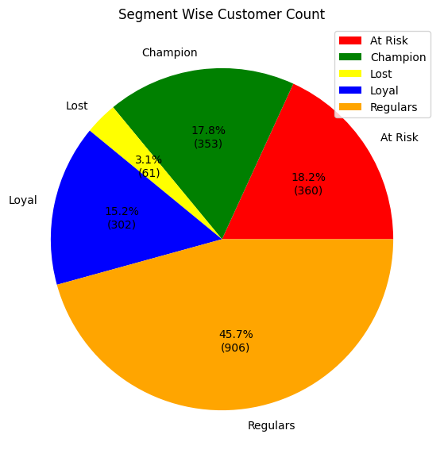

1. **Churn Probability**
   * **60.0% of customers are no-risk**, securing a strong base.
   * However, **18.3% fall under high churn risk**, requiring urgent intervention. 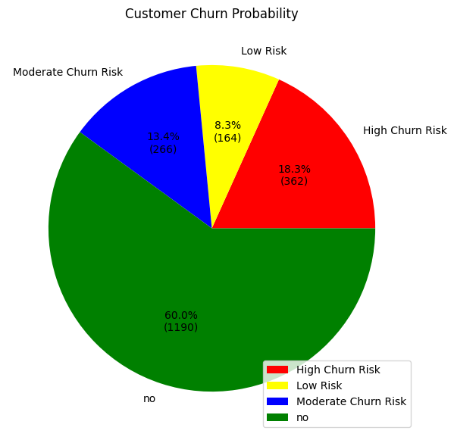
2. **Order Cancellations**
   * **Delhi ,Telangana and Maharashtra** record the highest cancellation volumes, negatively impacting profitability.

Cancellation and return percentages are notably high among **bad/low-value customers**. 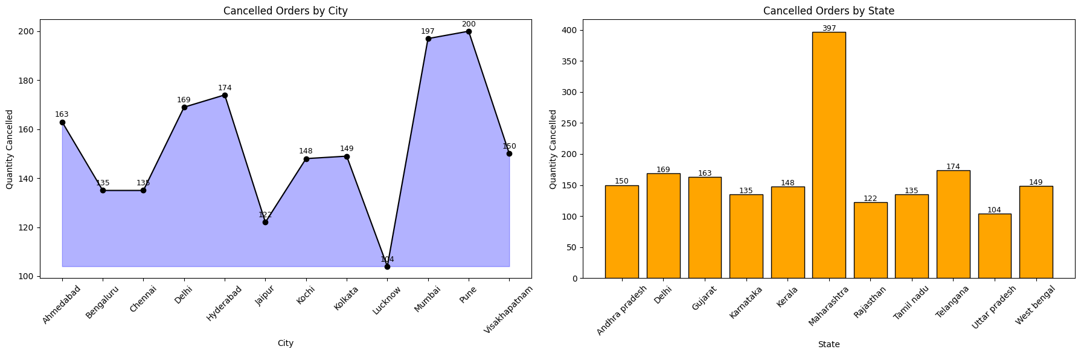

1. **Channel Performance**
   * **Online channel leads (4.83M)** in monetary value, slightly ahead of **Store (4.81M)**.
   * **Marketplace (4.79M)** underperforms, signaling lower customer trust or operational inefficiencies.

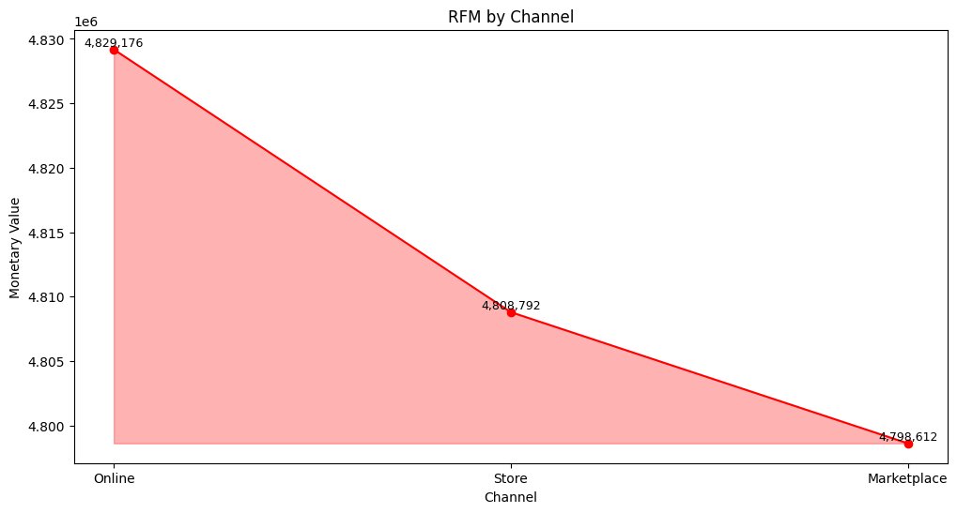

1. **High-Value Customers**
   * **Top 10 RFM customers** deliver disproportionately **high value (top customer 1.60K).**
   * Strong retention of this segment is critical to sustaining revenue.

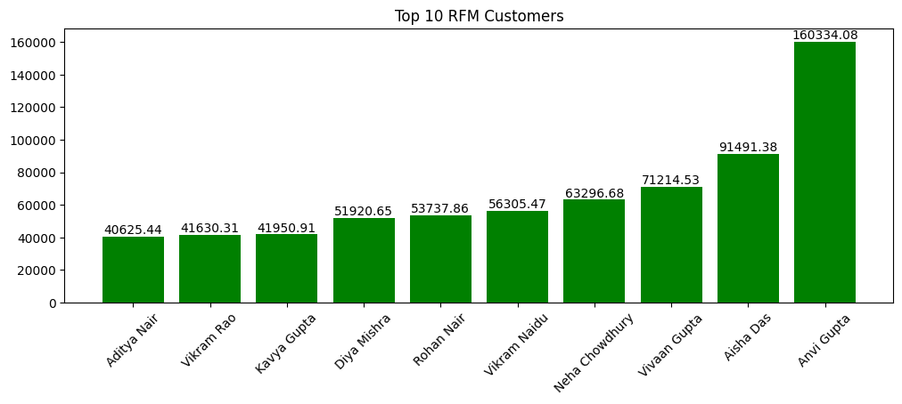

**Strategic Recommendations**

1. **Retention & Growth**
   * Implement **personalized loyalty programs** to convert “Regulars” into “Champions.”
   * Launch **win-back campaigns** for the **At-Risk** segment with targeted discounts, offers, and engagement initiatives.
2. **Churn Mitigation**
   * Deploy a **predictive churn model** to proactively identify and address high-risk customers.
   * Offer subscription packages, renewal benefits, or tailored service to retain the **18.3% at high risk**.
3. **Operational Improvements**
   * Conduct root-cause analysis of cancellations in **Delhi Telangana & Maharashtra** (logistics, quality issues, delivery delays).
   * Tighten **quality control** and improve **last-mile delivery efficiency**.
4. **Channel Optimization**
   * Revitalize **Marketplace strategy** with exclusive deals, faster fulfillment, and stronger customer service to close the performance gap.
5. **High-Value Customer Focus**
   * Establish **VIP recognition programs** for top RFM customers (priority support, premium offers, early product access).
   * Allocate account management resources to safeguard their loyalty and increase wallet share.

**Conclusion**

A **stable core of loyal customers** and strong **online channel performance**,But also a **significant churn risk**, **high cancellations in key states**, and an **underperforming Marketplace channel**.

By acting on these insights, leadership can:  
 Increase **customer lifetime value (CLV)**,  
 Reduce **revenue leakage from churn and cancellations**,  
 Strengthen **marketplace competitiveness**,  
 And grow the **Champions segment** into a sustainable long-term advantage.

Top of Form

Bottom of Form